Milestone Report: Typhoon

Kyle Sanger, Max Nowak, Trinity Burg, & Caleb Turecek

Edgewood College

Author Note

This is the final project for CS 480; Advanced Web Development Strategies- Fall 2022.

Abstract

This report will look at the groups’ website, *Typhoon*. *Typhoon* is being designed for people in the medical field. Whether they are performing clinicals or working full-time or part-time, this website can be used as a reference and/or for training purposes. *Typhoon* will be designed to work with a variety of different clinics, hospitals, and other community partners that have an affiliation agreement with Edgewood College. The website will also have their set of compliance requirements that must be met by students. The website is being designed to be easy to navigate, make things easy to find through list formation, and will to an extent be personalized as each user will have a log-in and password. As the website is still in the development process, there is currently code being worked on and fixed, some functions that are not quite perfect, and an overall looks that are still being finalized.

Typhoon

Over the course of a few months in the Advanced Web Development Strategies class at Edgewood College this fall. Group 2 has been developing the website *Typhoon* which will be used to organize and store information that medical students, medical professionals, and other people that will need information. This report will be looking over the functions of the website, the difference between the sites' functions for visitors verse owner, how the site works, how it is to be used, and updates.

# Use of Typhoon

The use of *Typhoon* will be different depending on if someone is visiting the website, has a relevant log-in or is the owner of the website. This will be seen as information that will be displayed on the website and what a user has access to. Say a person is a student using the *Typhoon*, if they have a log-in they will be able to see all the information that a visitor can without, but they will also have a spot to document their progress through clinicals, and they will receive information relevant to the location they are preforming clinicals at. If the user is a graduate or a person working full or part time they will have access to different types of medical information, but also procedures that their place of work enforces. Owners or programmers will be able to access most of the information and see how the website is being used.

## How Typhoon Works

Typhoon works to keep its users up to date on the latest trends, medical procedures/ techniques, out breaks, vaccines and any other medical information. This website allows for relevant information to be kept in a single location that is easy to access and use. From medical professionals to medical students, the requirements page will make it easy to know what needs to be done, and what may be required of everyone, as this section will be more customized based on place of employment, education status, and overall position.

How to use Typhoon. There is a video one can watch that goes over the general use and steps in using the website. Though for those that wish to read the instructions. The first step is to open the Typhoon. The second step is truly based on what one wants from the experience. It is recommended that the user either signs up or logs-in for the best user experience. This step will be under the admin button as of now. From there a user can look at the different sites linked to help find information they may be looking for about a certain procedure, medicine, or device on the Sites page or they can visit the requirements which will show students and forms, class stuff, or other work they need to complete for clinicals. Similar any full- or part-time person can find any forms they need to complete or review on the Requirements page. The Home page will have any important information that every person can see and may be changed depending on the organization. Different links, sources, and forms can be found by hovering over and or clicking on them, a keyboard may be needed if a section(s) of a form is not dropped down options.

There are a few updates that can be expected on Typhoon. A few minor things such as the color palate and fonts. The current website features Arial, Helvetica, or sans-serif for the logo, inherit as the dropdowns and other text is currently set to the default of each tag. The color palette will also be simplified to feature a more specific color scheme. Unlike its current state of various reds, whites, blues, blacks, browns, and grays. Other design aspects that will be updated for the next report will be the information sections that are currently different sizes with different font sizes and separate looks between pages. The goal is to have a more uniform look which will make it easier to navigate. See figures 1 and 2. These are just a few of the design's updates. Some code updates that will be worked on are the cookies and general information.

Though the updates to make the website function and look a certain way were discussed above there are a few updates that would be reoccurring. These updates will be seen as new information and procedures over the years. If a contract with a hospital, clinic, or other community partner changes or is voided. The information will be updated or deleted based on the situation.

Footnotes

There are multiple third-party links found on the website. However, they are not listed in this report.

Site Map

Site Map1

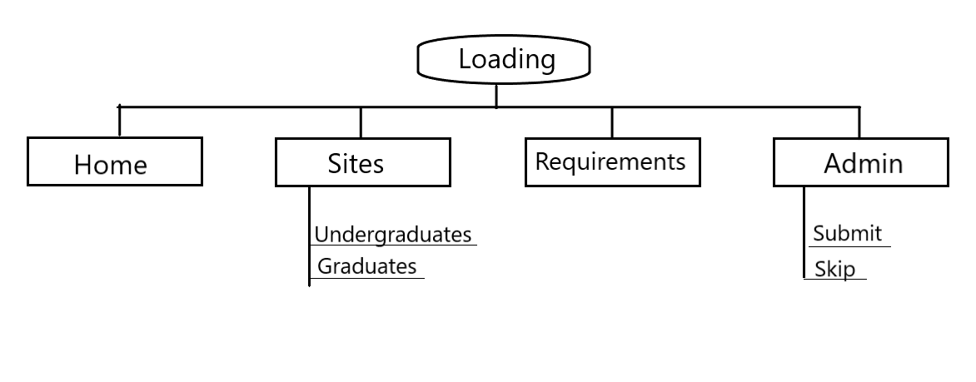

Note: This is a general flow of how the website Typhoon is linked through the site pages. Additional links are not seen as they are coded in different pages.

Figures

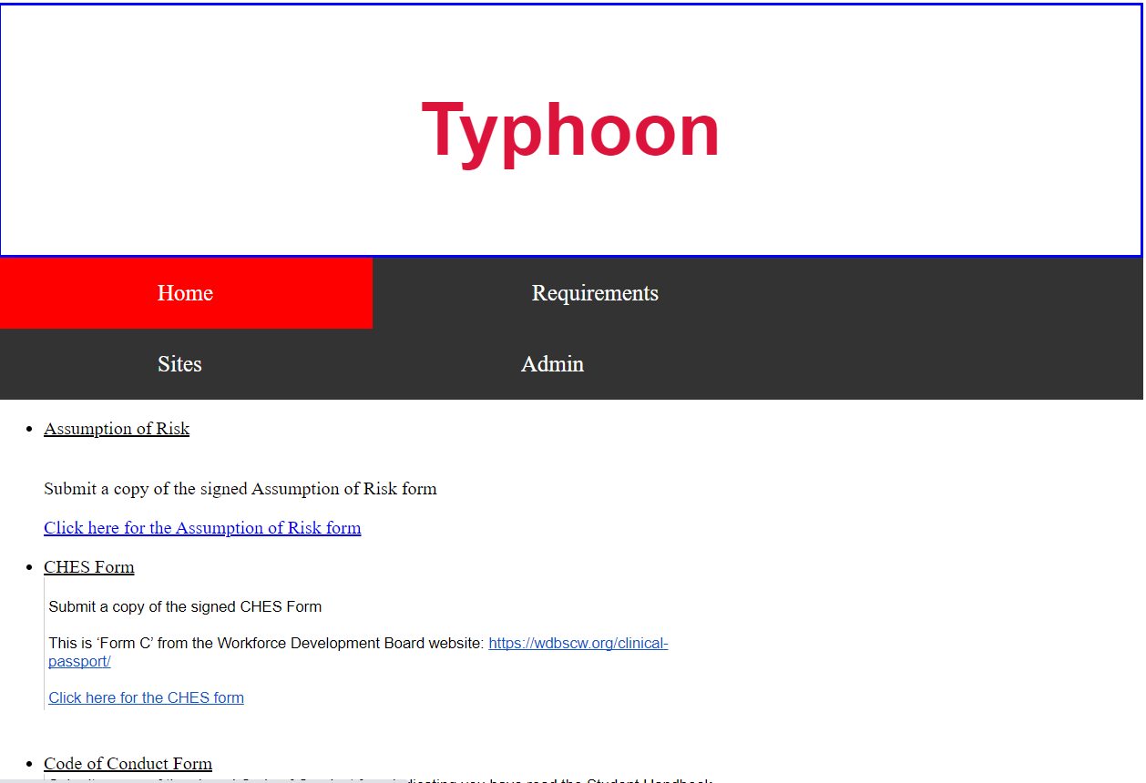

Figure 1. This is the Requirements page. This image shows the different links and information that can be seen. The Home button is currently being hovered over, so it is being highlighted in a red color.

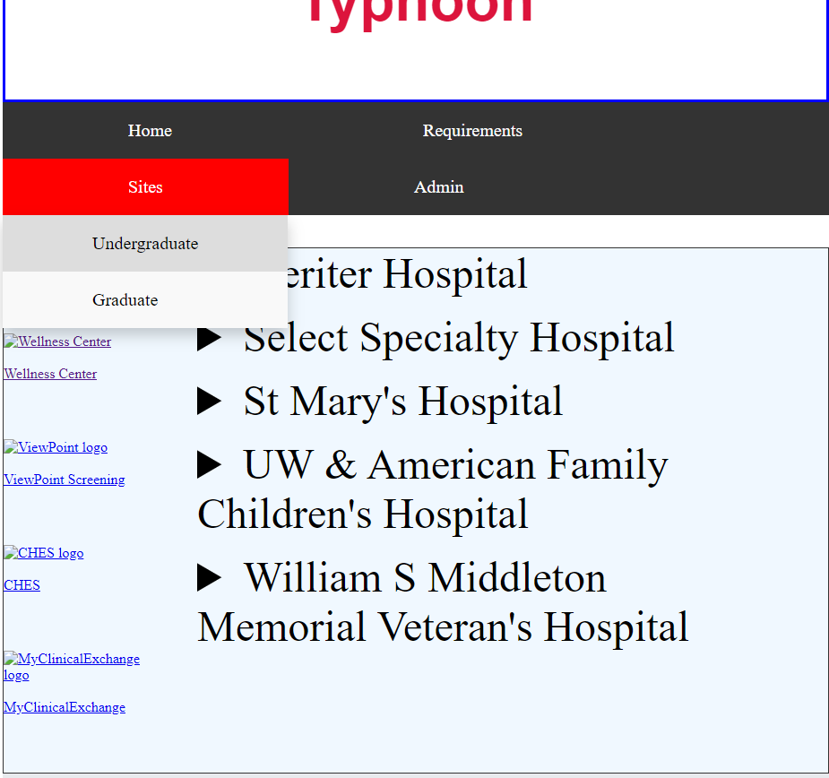

Figure 2. This is the Undergraduate page. This image shows the different links and information that can be seen. The large text with arrows is dropdown sections that have text that decreases by level of link. The Sites page is being hovered over, which causes it to be red and display its dropdown of Undergraduate and Graduate subcategories. The Undergraduate subcategory is a darker gray as it is being hovered over.